Revised March 2016
The Hirer of the Centre agrees that:
- The premises have been inspected and are suitable for the purpose of hire.
- The premises will not be used for any purpose other than that stated in 'purpose of hire' and within the times stated.
- The maximum number of people allowed in the hall is 100 (fire safety)
- No bouncy castles, or other unauthorised electrical appliances or combustible materials are used (insurance restraints, and fire safety)
- No smoke machines, or similar equipment issuing particles or dust will be used (due to such equipment setting off the fire alarm)
- The Hirer, or someone authorised by the hirer, will be present and responsible throughout the period of hire and order will be preserved.
- Members of the committee or volunteers are allowed access to the building at any time during the period of hire.
- Other users of the Centre are allowed access to the WCs and Kitchen.
- The booking is only confirmed when the hire fee has been paid.
- Bookings cancelled within 72 hours of the hire date are subject to retention of a booking fee of £10.

The Hirer is responsible for:
- Ensuring when the hire is outside Centre opening hours that no unauthorised person has access to the building.
- Ensuring that those attending their session sign in and out of the building.
- Any music, performance or other licence that may be required (private parties excluded).
- Setting up and clearing away tables and chairs and leaving the premises clean and tidy
- On leaving, checking electrical appliances and lights are turned off, windows and exit door are secured.
- Any damage done to the ‘Centre of Pendeen’ or its belongings arising from this hire as well as the expense of making good such damage.

In an emergency:
- The Centre Key Holders are listed in the window by the reception entrance door.
- When the fire alarm sounds, the building must be evacuated.
- When the hire is outside Centre opening hours the Centre phone will not be accessible, so please have a fully charged mobile phone available if possible.
- If necessary the emergency services can contacted by phone from the North Inn, the square outside of which is the emergency assembly area.

Please retain the document Precautions and Procedures in the event of a fire

Revised March 2016

Centre of Pendeen

Precautions and Procedures in the event of a fire
The Centre Committee cannot take responsibility for the safety of any hiring group, but is required to supply information to ensure that as a Hirer of the Centre of Pendeen you are aware of fire precautions and procedures.

Please note:
- The Hirer is responsible for the safety, and evacuation of all persons attending their session in an emergency.
- The Hirer should check that emergency escape routes are not obstructed, exit doors are not locked, fire fighting equipment is in place, accessible and not interfered with.
- People present for the hire will be made aware of the Fire Action notice (situated by manual call points), site of fire appliances, manual call points, emergency exits and fire assembly point
- Hirers should have persons within their group who will act as stewards in the event of a fire

In the event of a fire
- Sound the alarm – Manual Call Points are by Road and Front Doors
- Call the Fire Brigade – 999
- Check evacuation is in progress
- Attack the fire with the appliances provided, if safe to do so – ensure your escape route remains clear.

Emergency evacuation procedure
- Leave the building, quickly and calmly
- Do not stop to collect belongings
- The hirer should check all ground floor rooms and WCs for occupants
- Shut doors behind you
- Take your attendance record with you to use when you’re safely away from the building
- Assemble in The Square, outside the North Inn, for head-count.
- Please make sure you have everyone in your party before anyone leaves the assembly point.

DO NOT RE-ENTER THE BUILDING UNTIL AUTHORISED

Plan of Hall Fire Safety Information (overleaf) Revised March 2016

PLAN of HALL - FIRE SAFETY INFORMATION

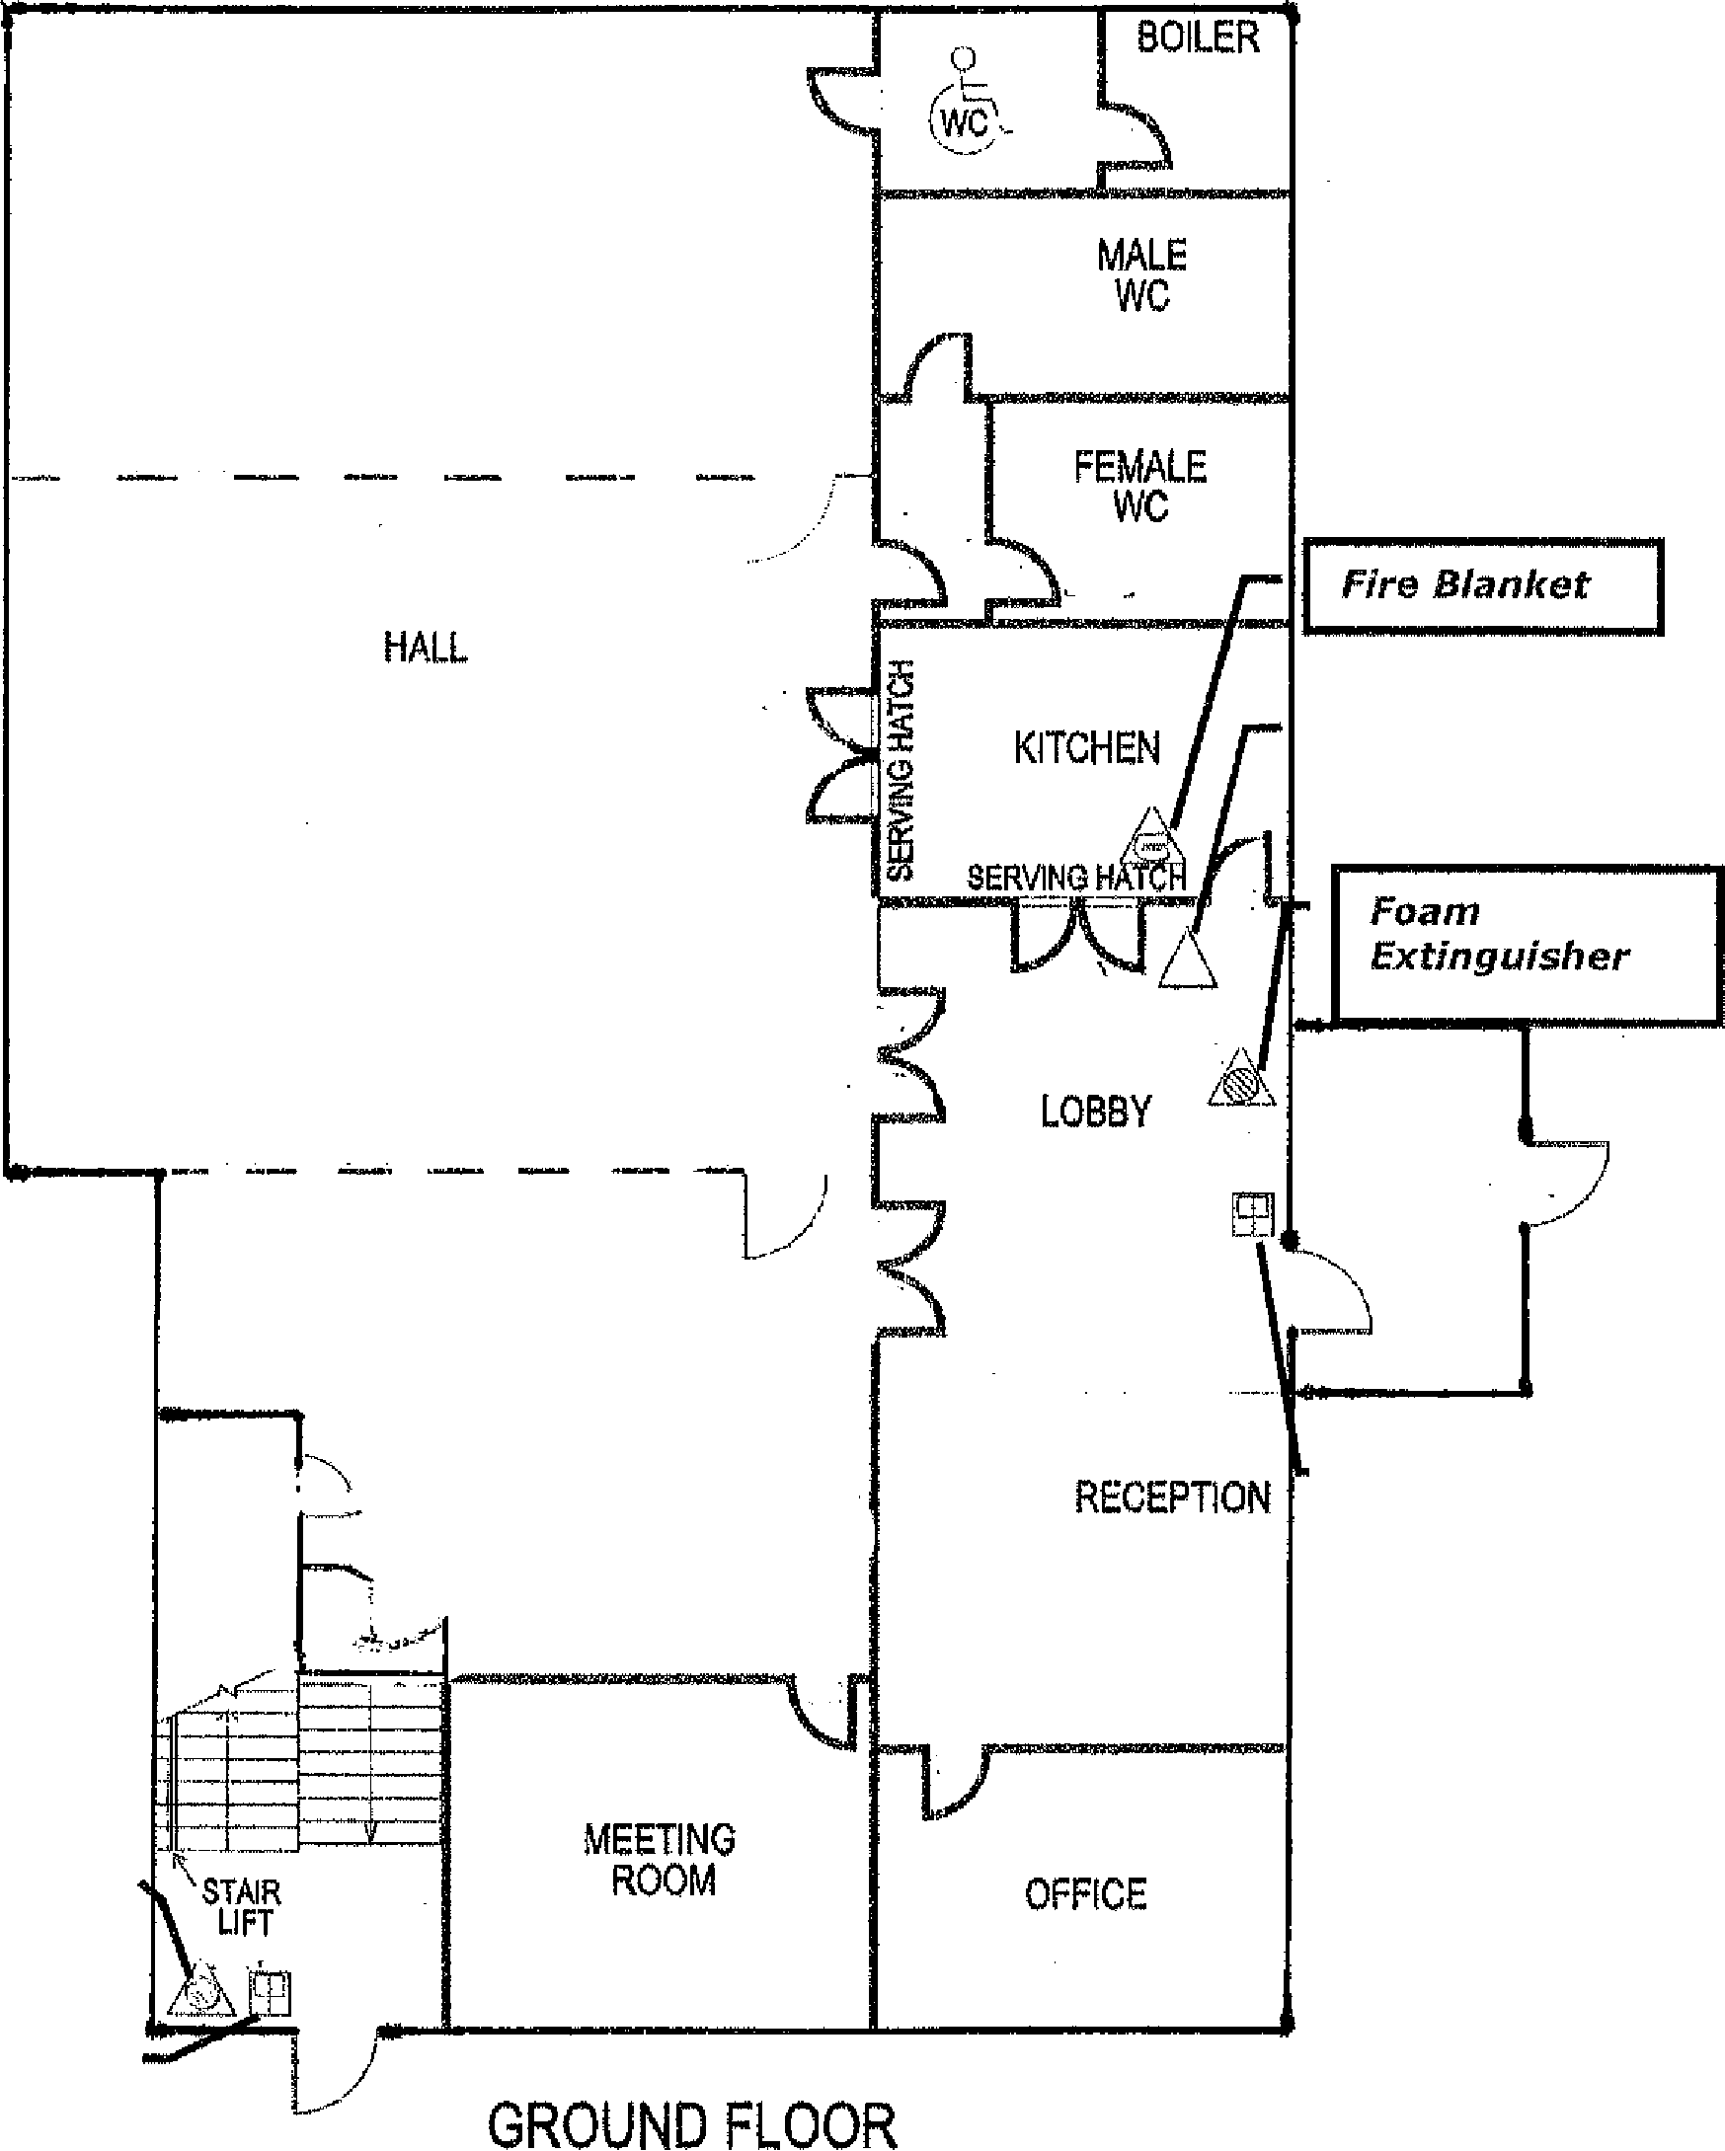
Foam Extinguisher
Manual Call Point
Cleaner’s cupboard
door to be kept locked
Fire
Exit
Fire
Exit
Fire
Exit
Manual Call Point
Fire
Exit

HALL sea view

SCREEN

Carbon Dioxide Extinguisher

SCREEN

HALL Front

Precautions and Procedures in the event of a fire (overleaf) Revised March 2016

